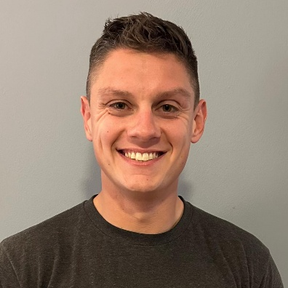

Education

certifications

Professional Overview
Short, sweet, and straight to the point. Keep this section at roughly 2-3 sentences

Experience

Title of Position Held

Organization, City, State | Month Year – Month Year
- Description of Tasks
- Use Keywords/terms
- Include sports you worked with
- Include other responsibilities outside of coaching, such as budgeting, social media, etc.

Title of Position Held

Organization, City, State | Month Year – Month Year
- Description of Tasks
- Use keywords/terms
- Include sports you worked with
- Include other responsibilities outside of coaching, such as budgeting, social media, etc.

Title of Position Held

Organization, City, State | Month Year – Month Year
- Description of Tasks
- Use keywords/terms
- Include sports you worked with
- Include other responsibilities outside of coaching, such as budgeting, social media, etc.

Contact

Name
credentials

systems used

Internships

Title of Position Held

Organization, State | Month Year – Month Year
- Description of Tasks
- Include ALL Sports assisted with
- Include tech and other responsibilities

Title of Position Held

Organization, State | Month Year – Month Year
- Description of Tasks
- Include ALL Sports assisted with
- Include tech and other responsibilities

Title of Position Held

Organization, State | Month Year – Month Year
- Description of Tasks
- Include ALL Sports assisted with
- Include tech and other responsibilities

Public speaking

name
credentials

leadership roles/athletic experience

Title of Position Held

Organization, State | Month Year – Month Year
- Description of Tasks
- List awards or big achievements

Title of Position Held

Organization, State | Month Year – Month Year
- Description of Tasks
- List awards or big achievements

